Enhancing Rip Current Analysis in Drone Imagery via Deep Spectral-Spatial Wavelet Integration

Yonatan Ben Avraham Baruch Binyaminov

Abstract

Rip currents are a leading cause of coastal fatalities worldwide, necessitating effective real-time monitoring solutions. Traditional visual detection remains challenging due to the low contrast between the calm rip surface and surrounding breaking waves. This study proposes a novel framework utilizing spectral-spatial fusion for both rapid classification and precise localization of rip currents. Building on the established utility of wavelets for hydrodynamic feature extraction, we investigate the optimal strategy for integrating Discrete Wavelet Transform (DWT) features into Deep Learning architectures. We evaluate distinct fusion approaches ranging from a computation-efficient "Channel Replacement" strategy to a robust Dual-Stream architecture with Attention mechanisms. These methods are validated against a standard RGB baseline using a custom CNN for presence detection and a YOLOv8 model for object localization. Experimental results demonstrate that correctly fusing spectral features significantly outperforms both standard RGB baselines. The Dual-Stream architecture achieves superior classification performance with over 95.5% accuracy, while the Channel Replacement method proved to be the most effective strategy for the YOLOv8 detection model, enhancing localization precision. Furthermore, Explainable AI (XAI) analysis confirms that the models correctly localize currents based on physical wave gaps. This work bridges deep learning with physical oceanography, proving that spectral feature integration is key to robust autonomous coastal safety.

Keywords: Rip currents, YOLOv8, CNN Classification, Wavelet Transform, Object Detection, Explainable AI (XAI).

Introduction

Rip currents are powerful, narrow channels of fast-moving water prevalent along beaches worldwide. They represent one of the most hazardous coastal phenomena, responsible for approximately 80% of beach-related rescues and a substantial number of drowning fatalities annually [1,2]. Despite their significant danger, rip currents remain notoriously difficult to detect visually, especially for untrained beachgoers. They often lack clear surface signatures, appearing deceptively calm compared to the surrounding breaking waves [3]. This visual ambiguity is particularly critical on crowded public beaches, where the timely and accurate identification of these hazards can directly influence safety operations and prevent loss of life.

Historically, coastal monitoring relied on in-situ measurements using Acoustic Doppler Current Profilers (ADCPs) or GPS drifters [4]. While these methods provide high-accuracy flow data, they suffer from limited spatial coverage, high deployment costs, and are impractical for real-time public monitoring. Consequently, the field has shifted toward remote sensing techniques. Traditional optical systems, such as time-averaged photography (TIMEX), have been widely used to visualize breaking wave patterns [5]. However, these methods typically rely on manual interpretation or handcrafted heuristics, making them sensitive to variable lighting conditions, camera angles, and local beach morphology.

In recent years, the advent of Deep Learning (DL) has revolutionized object detection in maritime environments. Convolutional Neural Networks (CNNs) and detectors like Faster R-CNN and YOLO have demonstrated promising results in automating rip current detection [6,7]. Nevertheless, standard DL models operating on RGB imagery face inherent limitations. They often struggle to distinguish the subtle texture of a rip channel from the noise of breaking waves, leading to false negatives in complex sea states. Furthermore, deep models are frequently criticized for being "black boxes," lacking the interpretability required for safety-critical applications [8].

To address the limitations of RGB-only analysis, recent research has revisited classical signal processing techniques. Notably, Wang et al. (2025) demonstrated that the Discrete Wavelet Transform (DWT) can effectively extract hydrodynamic features by highlighting the texture gradients between high-energy breaking waves and the lower-energy rip channel [9]. While their work established the physical utility of wavelets, it relied on traditional convolution and thresholding, which may lack the generalization capabilities and speed of modern data-driven architectures.

This study proposes a novel hybrid framework that bridges the gap between physical oceanography principles and advanced deep learning. We investigate optimal strategies for embedding spectral texture information into neural networks. We introduce and compare distinct fusion approaches, including a computation-efficient "Channel Replacement" strategy, where the Red channel is substituted with a DWT-based energy map - and a robust "Dual-Stream" architecture that processes spatial and spectral features in parallel. The primary aim of this work is to demonstrate that fusing spectral wavelet features with deep learning significantly enhances detection performance compared to standard RGB baselines. Our results show that this approach achieves superior precision and recall suitable for real-time drone-based monitoring. Furthermore, we employ Explainable AI (XAI) techniques, specifically Eigen-CAM, to validate that the models correctly identify rip currents based on physical wave gaps rather than environmental artifacts.

Literature Review

Rip current research spans coastal geomorphology, optical physics, and computer vision. Early studies established the foundational understanding of rip morphology and circulation patterns. Scott et al. [1] and recent critical reviews [New-1] provide comprehensive overviews of the physical mechanisms driving rip channels, outlining key visual indicators-such as darker gaps in breaking waves or seaward-moving sediment plumes-that serve as the ground truth for automated detection. Complementing empirical observation, numerical approaches like Boussinesq modeling [New-3] have been used to simulate rip occurrences on featureless beaches, though such hydrodynamic models are often computationally intensive for real-time monitoring.

Crucial to visual detection is the understanding of how light interacts with water. Foundational optical studies by Pope and Fry [Physics-1] demonstrated that water absorption increases strongly toward longer wavelengths; consequently, red light attenuates significantly faster than blue or green light in aquatic environments. This optical property explains why red channels in RGB imagery often contain the least structural information regarding underwater features. Conversely, the blue channel is frequently utilized in marine studies, such as dye tracking methodologies [Physics-2], due to its superior penetration. This physical justification underpins strategies that treat the red channel as redundant or replaceable in multi-spectral analysis of coastal imagery.

The transition to automated detection began with rule-based heuristics. An early 2005 patent [2] proposed using handcrafted color and texture cues, marking early interest in image-driven analysis. Systematic academic attempts emerged with Maryan et al. [3], who demonstrated that even shallow Convolutional Neural Networks (CNNs) outperform classical feature-based models like SVMs. Subsequent deep learning advancements focused on temporal dynamics and interpretability. De Silva et al. [4] introduced a Faster R-CNN framework with temporal aggregation to stabilize detections in dynamic surf, while RipViz [6] incorporated optical flow and LSTM autoencoders to model water movement. To address the "black box" nature of these models, Rampal et al. [5] applied Explainable AI (XAI) techniques, using Grad-CAM to visualize the spatial regions driving predictions-a critical step for operational trust.

Recent literature emphasizes the deployment of lightweight models on Unmanned Aerial Vehicles (UAVs) and edge devices. RipFinder [8] and RipScout [New-8] presented mobile-ready frameworks for real-time detection, highlighting the shift towards accessible coastal surveillance. Similarly, [New-4] explored IBN-driven analysis using UAVs for next-generation surveillance. The field is currently advancing towards precise segmentation and optimization of modern architectures. The 2025 RipSeg Challenge [New-2] and Dumitriu et al. [9] established benchmarks for dense segmentation using YOLOv8, enabling the mapping of exact rip contours. Furthermore, recent studies on small datasets [New-6] have investigated optimizing data augmentation parameters specifically for YOLOv11, demonstrating that modern detectors can be fine-tuned for high performance even with limited coastal data.

Parallel to deep learning, wavelet-based methods remain highly relevant for their computational efficiency and ability to capture physical textures. Wang et al. [7] utilized the Discrete Wavelet Transform (DWT) to extract directional water-flow features, effectively enhancing breaker fronts while suppressing background noise. Their work highlights that wavelets can capture hydrodynamic gradients that pure RGB models might miss.

This study synthesizes these domains by bridging the gap between physical optics and modern deep learning. While Wang et al. [7] demonstrated the feature extraction capabilities of wavelets, their integration into end-to-end deep neural networks remains underexplored. Building on the optical principles regarding channel information [Physics-1], we investigate optimal strategies for fusing spectral and spatial data. We propose and compare a computation-efficient "Channel Replacement" strategy against a robust "Dual-Stream" architecture equipped with attention mechanisms. By embedding physical texture features into both custom classifiers and advanced object detectors (YOLOv8), we aim to enhance detection accuracy and robustness while evaluating the trade-offs suitable for UAV-based monitoring.

Background

3.1 Discrete Wavelet Transform (DWT)

Unlike the traditional Fourier Transform, which captures global frequency information but loses temporal (or spatial) localization, the Discrete Wavelet Transform (DWT) allows for simultaneous analysis of signal frequency and spatial location. This property is particularly crucial for analyzing coastal imagery, where hydrodynamic features such as breaking waves and rip channels create localized, non-stationary texture patterns.

Mathematically, the decomposition is performed by convolving the signal with a low-pass filter (g) and a high-pass filter (h), followed by dyadic down sampling. For a discrete signal x[n], the decomposition coefficients are given by:

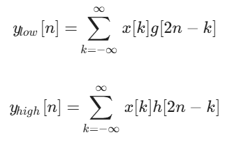

In two-dimensional image analysis, this operation is applied sequentially along the rows and then the columns of the input image I(x, y). This process results in four distinct sub-bands at each decomposition level:

Approximation (LL): Represents the low-frequency structural components.

Horizontal Detail (LH): Captures horizontal edges and changes.

Vertical Detail (HL): Captures vertical edges.

Diagonal Detail (HH): Captures diagonal features and high-frequency noise.

This process can be repeated recursively on the approximation sub-band (LL), a technique known as Multi-Resolution Analysis (MRA). This allows the model to capture features at various scales-coarse structures at deeper levels and fine textures at shallower levels.

3.2. Choice of Wavelet Basis

While many wavelet families exist, this study utilizes the Daubechies (db) family. Unlike smooth wavelets (e.g., Haar or Gaussian), Daubechies wavelets possess compact support and vanishing moments, making them exceptionally effective at detecting discontinuities and sharp localized changes-characteristics typical of the turbulent interface between rip currents and breaking waves.

4. Methodology

Dataset
To ensure consistent benchmarking and reproducibility, this study utilizes the Rip Current Monitoring dataset (Version 1), publicly available on the Roboflow platform. The dataset comprises 2,246 aerial coastal images capturing a wide range of environmental conditions, including varying water turbidity, lighting, and sea states.
The data was split into training, validation, and testing sets following the official provider's ratio to prevent data leakage.
  - Training: 1,566 images
  - Validation: 453 images
  - Testing: 227 images
All images were preprocessed to a uniform resolution of 320x320 pixels with EXIF orientation removed. Annotations were provided in YOLO format for the object detection task. For the binary classification task, image-level labels were derived based on the presence of bounding boxes. The dataset exhibits a class imbalance, with approximately 69% of the samples labeled as 'Positive' (containing rip currents) and the remaining 31% as 'Negative'. This distribution necessitates the use of robust evaluation metrics, such as the F1-score, to strictly assess model performance beyond simple accuracy.

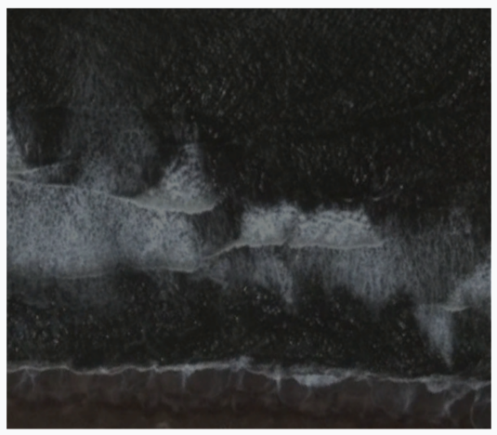
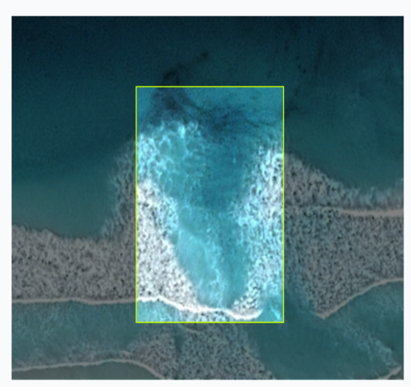
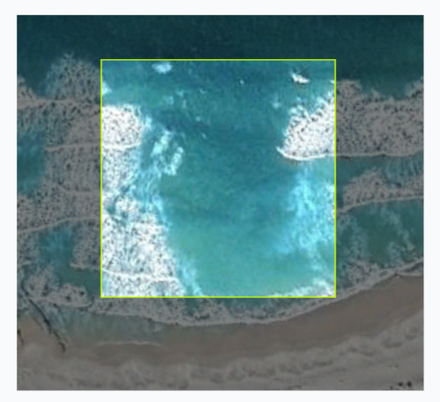
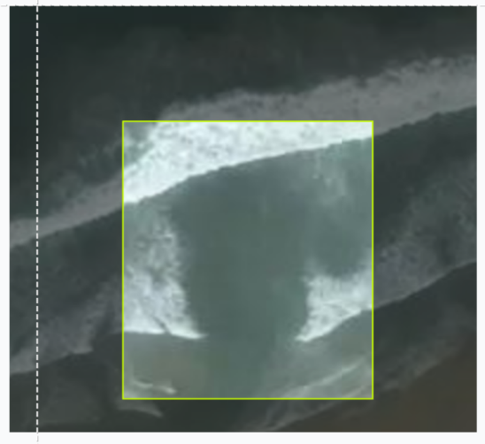
Figure 1: presents representative samples from the dataset. As shown, the visual distinction between rip currents (top row) and safe breaking waves (bottom row) is often subtle, necessitating the use of the proposed spectral-spatial feature extraction methods.
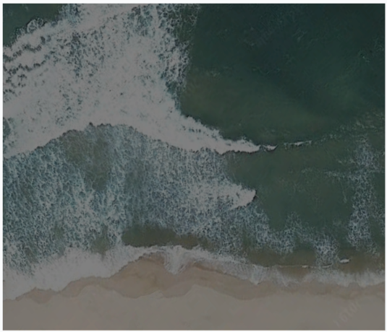
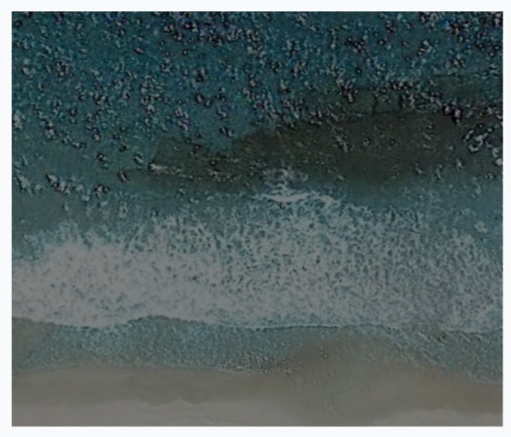

  - Feature Engineering: The Channel Replacement Strategy

Building on the theoretical absorption properties discussed in Section 3, we implement a targeted "Channel Replacement" strategy. Since the Red channel (R) contains minimal bathymetric features and is dominated by surface reflection noise, we substitute it with the Wavelet Energy Map (W) derived from the DWT high-frequency sub-bands.
Formally, given an input RGB image I_{RGB}, the transformed input I_{New} is constructed as:
I_{New} = Concat(W, G, B)
This technique embeds spectral texture information explicitly into the input layer, allowing standard 3-channel CNN backbones (like YOLO or ResNet) to process hydrodynamic features without requiring architectural modification.

Diagram 1: showing the idea of channel replacement

  - Network Architectures
For Binary Classification: We developed a custom Dual-Stream CNN capable of fusing spatial (RGB) and spectral (Wavelet) features in parallel. Additionally, we evaluated a Single-Stream variant adapted to process the Channel-Replaced input for comparative analysis.
For Object Detection: We utilized the YOLOv8 architecture, specifically configuring its input layer to accept the Channel-Replaced composite images, thereby embedding hydrodynamic texture data directly into the detector's backbone.

    - Classification Models -
The core of our classification framework is the Dual-Stream Architecture, designed to explicitly leverage both visual appearance and hydrodynamic texture. As illustrated in Figure 2, the network comprises two parallel branches:
- The Spatial Stream: A CNN branch processing the standard 3-channel RGB input to capture color and shape features.
- The Spectral Stream: A parallel CNN branch processing the 4-channel Wavelet stack (LL, LH, HL, HH) to extract frequency-domain texture gradients.
Both streams utilize identical backbone structures consisting of convolutional layers followed by batch normalization and ReLU activation. The feature maps from both streams are fused via a concatenation layer, creating a unified representation that is subsequently fed into the Attention Module (detailed in Section 4.4) and a fully connected classifier.

To rigorously evaluate the effectiveness of the dual-stream fusion strategy, we implemented four distinct Single-Stream configurations for comparison:
- RGB Baseline: A standard CNN processing only spatial information (3 channels), representing the common approach in current literature.
- Pure Wavelet: A network processing only spectral features (4 channels), testing the hypothesis that texture alone is sufficient for detection.
- Early Fusion (4-Channel Stack): A model where the Wavelet energy map is concatenated with the RGB channels at the input level (R, G, B, W). This tests whether performance gains stem merely from data availability or from the architectural separation.
- Channel Replacement: A model utilizing the 3-channel composite input (W, G, B) defined in Section 4.2. This configuration evaluates the efficiency of discarding the Red channel in favor of spectral data within a standard CNN architecture.

Figure 2: Dual-Stream Architecture
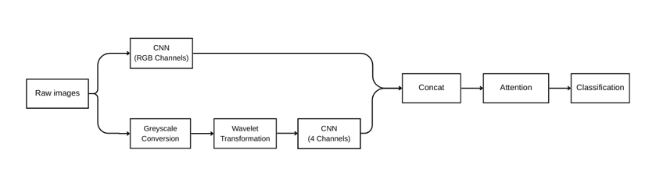
4.3.2 Object detection model (YOLOv8): short description about YOLO, the hyperparameters and how we fed the replacement images to it.
4.4 Attention Mechanism (CBAM)
A short description of the Attention Mechanism we added.
4.5 Comparative Integration Strategies
To rigorously evaluate the effectiveness of the proposed replacement strategy, we investigated alternative fusion methods:
- HSW (Hue-Saturation-Wavelet): Instead of RGB space, we converted images to HSV and replaced the Value (V) channel-which correlates with brightness-with the Wavelet map (W), aiming to decouple color from texture intensity.
- Early Fusion (4-Channel Input): We concatenated the Wavelet map as a fourth channel (R, G, B, W) to preserve all original information.
- Image Fusion: We applied pixel-level fusion techniques to blend the Wavelet features into the RGB image prior to input.
These configurations serve as baselines to demonstrate that explicit channel substitution (Section 4.2) and dual-stream processing (Section 4.3.1) yield superior feature representation for rip current analysis.

5. Experimental Setup
- Training configuration (optimizer, epochs, batch size, loss function, hyperparameters).
- Data preprocessing.
- Evaluation metrics (Accuracy, F1, mAP).

6. Results
6.1 Classification performance

 | Accuracy | F1 | Precision | Recall
Single Stream (RGB) | 90.3% | 93% | 91.87% | 94.23%
Single Stream (Wavelet) | 78.8% | 85.7% | 80% | 92.3%
Single Stream – Wavelet, R, G, B | 87.2% | 91.34% | 85.5% | 98%
Single Stream – Channel Replacement | 94.7% | 96.23% | 94.4% | 98.08%
Dual Stream | 95.59% | 96.87% | 94.5% | 99.36%

6.2 Detection performance

 | mAP 50 | mAP 50-95 | Precision | Recall | FPS
YOLO-n | 92.24% | 45.48% | 84.94% | 89.1% | 74.75
YOLO-s | 93.14% | 45.91% | 89.71 | 89.42% | 38.19
YOLO-n – Image Fusion | 90% | 42.34% | 89.07% | 83.62% | 66.72
YOLO – n –  Channel Replacement | 93.5% | 45.45% | 87.29% | 92.44% | 71.4
YOLO-n (Wavelet) | 88.85% | 42.74% | 87.04% | 81.77% | 65.06
YOLO-n (HSW) | 83.61% | 37.07% | 84.15% | 74.87% | 50.93

6.3 FLOPs/time comparison
6.4 Explainable AI (XAI) Analysis
GradCAM and EigenCAM

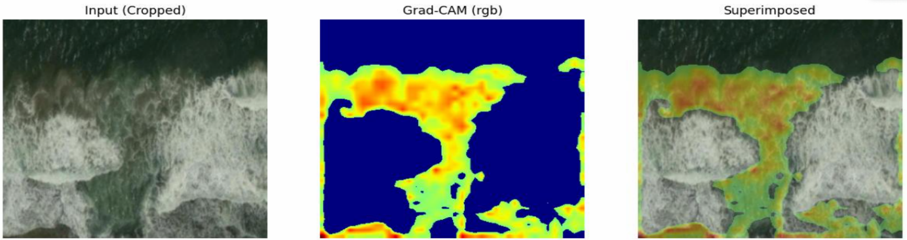
GradCAM:

EigenCAM:
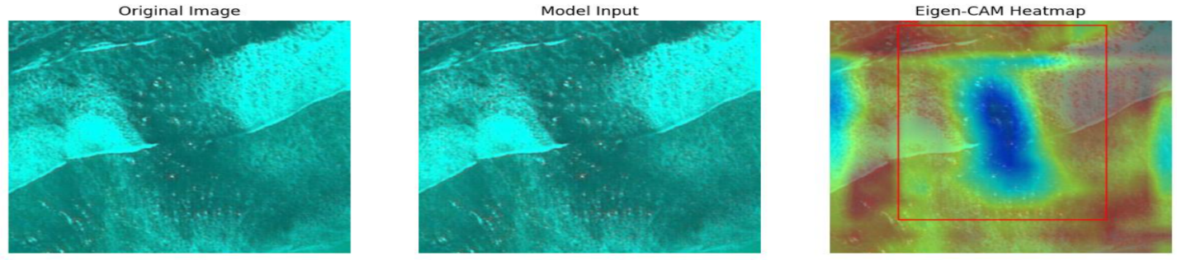

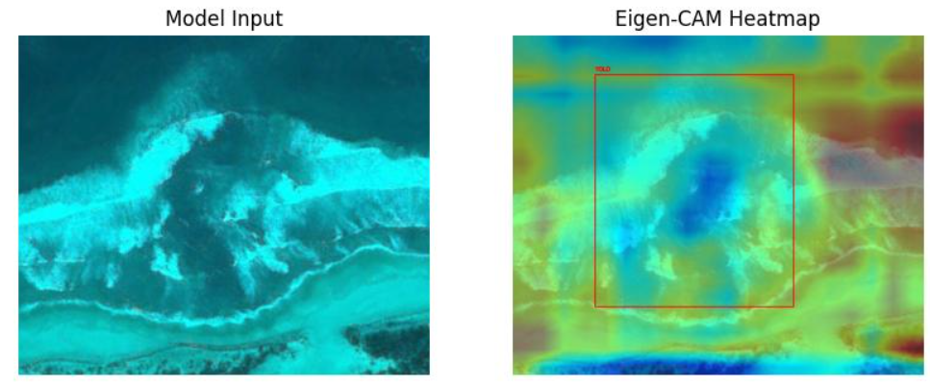

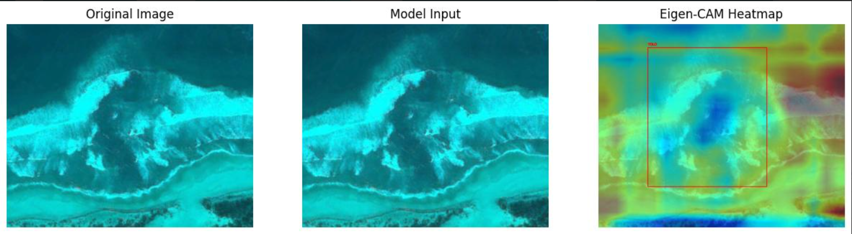

7. Discussions and Conclusions

Data Preprocessing
To adapt the dataset for binary classification, the following preprocessing pipeline is applied:
- Label Conversion:
YOLO annotations are converted into a binary label. Images containing one or more bounding boxes are labeled Rip Current, while images with no annotations are labeled No Rip Current.
- Normalization:
Images are kept at 320×320 resolution and normalized to the range [0, 1].
- Channel Preparation:
Each sample is prepared in two forms:
  - the original RGB (3-channel) image,
  - a grayscale (1-channel) version used for wavelet computation.
- Data Augmentation:
To improve generalization and reduce overfitting, online data augmentation is applied only to the training set. The following transformations are used with random probabilities:
- horizontal flips (to account for left-right symmetry of the surf zone),
- small rotations (e.g., ±5–10°) to model slight camera tilts,
- Light random cropping or zoom to introduce spatial variability while preserving the surf zone.
Labels are kept unchanged, and all augmentations are applied consistently to the RGB and grayscale inputs of the same sample.

Wavelet-Based Feature Extraction
To incorporate frequency-domain information, a 2-level 2D Discrete Wavelet Transform (DWT) is applied to the grayscale image. Following prior findings in coastal texture analysis, the Daubechies (db4) wavelet is selected.
The extraction process is defined as follows:
- Grayscale Input:
A normalized grayscale tensor is used for the transform.
- 2-Level Decomposition:
The DWT produces approximation and detail coefficients at each level. From the second level, we collect:
  - LL₂ (approximation)
  - LH₂ (horizontal detail)
  - HL₂ (vertical detail)
  - HH₂ (diagonal detail)
- Wavelet Map Construction:
The four coefficient matrices are resized to 320×320 and stacked into a 4-channel Wavelet Map.
This wavelet representation forms the input to the secondary model branch.

Model Architecture
A Dual-Stream Convolutional Neural Network (CNN) is proposed to fuse spatial (RGB) and frequency-domain (wavelet) information.
Stream A: RGB Branch
The RGB image (320×320×3) is processed through a sequence of convolutional layers with ReLU activation and Max Pooling, enabling extraction of spatial and color-based features.

Stream B: Wavelet Branch
The Wavelet Map (320×320×4) is processed by a parallel convolutional stream designed to learn texture- and structure-based cues present in the wavelet coefficients.

Fusion, Optional Attention and Classification
The output feature vectors from both branches are flattened and concatenated.
Optionally, a lightweight attention module is applied to this fused feature vector before classification. In this configuration, the concatenated features are passed through a simple attention block (e.g., channel-wise or channel-spatial attention) that reweights feature dimensions according to their estimated importance. The attention-refined representation is then forwarded to the classifier.
Finally, the (optionally attended) fused feature vector is passed through fully connected layers with Dropout regularization. A final Sigmoid unit outputs the predicted probability of rip-current presence.
This setup allows us to compare a baseline fusion model (without attention) against an attention-enhanced variant, and to quantify the contribution of the attention mechanism in an ablation study.

Training Configuration and Evaluation
All experiments are conducted using PyTorch with GPU acceleration.
  - Loss Function: Binary Cross-Entropy (BCE)
  - Optimizer: Adam, initial learning rate 0.001
  - Batch Size: 32
  - Epochs: Up to 50, with Early Stopping based on validation loss (patience = 5) Evaluation Metrics
Performance is evaluated on the test set using:
  - Accuracy
  - Precision
  - Recall
Recall is emphasized due to the importance of minimizing false negatives in safety-critical rip-current detection.

References
[1] Scott, T., Masselink, G., Austin, M., & Russell, P. (2009). Rip Current Hazards.
[2] US Patent US20050271266A1 (2005). System and Method for Detecting Rip Currents from Images. [3] Maryan, C. (2018). Detecting Rip Currents from Images (Master’s thesis); Maryan, C., Hoque, M., Michael, C., Ioup, E., & Abdelguerfi, M. (2019). Machine Learning Applications in Detecting Rip Channels from Images.
[4] De Silva, A., Mori, I., Dusek, G., Davis, J., & Pang, A. (2021). Automated Rip Current Detection with Region-based Convolutional Neural Networks.
[5] Rampal, N., Shand, T., Wooler, A., & Rautenbach, C. (2022). Interpretable Deep Learning Applied to Rip Current Detection and Localization.
[6] De Silva, A., Zhao, M., Stewart, D., Khan, F., Dusek, G., Davis, J., & Pang, A. (2023). RipViz: Finding Rip Currents by Learning Pathline Behavior.
[7] Wang, H. M., Doong, D. J., & Lai, J. W. (2025). Rip Current Identification in Optical Images Using Wavelet Transform. Journal of Marine Science and Engineering, 13(4), 707.
[8] Khan, F., De Silva, A., Palinkas, T., Dusek, G., Davis, J., & Pang, A. (2025). RipFinder: Real-Time Rip Current Detection on Mobile Devices.
[9] Dumitriu, M., Tatui, I., Miron, A., Ionescu, R., & Timofte, R. (2025). Rip Current Segmentation: A Novel Benchmark and YOLOv8 Baseline Results.

• [Physics-1] Pope, R. M., & Fry, E. S. (1997). Absorption spectrum (380–700 nm) of pure water. II. Integrating cavity measurements. Applied Optics.
• [Physics-2] Kim, H. D., & Kim, K. H. (2021). Analysis of rip current characteristics using dye tracking method. Atmosphere.

• [New-1] A Critical Review of Challenges... (Use this alongside Scott et al.)
• [New-2] AIM 2025 Rip Current Segmentation (RipSeg) Challenge Report
• [New-3] Assessing Rip Current Occurrences... Boussinesq Modeling
• [New-4] IBN-Driven Rip Current Analysis Using UAVs...
• [New-6] Optimizing Data Augmentation Parameters in YOLOv11...
• [New-8] RipScout: Realtime ML-Assisted...

